


NATIONAL CERTIFICATE (VOCATIONAL)

FUNDAMENTALS

MATHEMATICS

NQF LEVEL 2
7 P2 (V1)
TASK:

DATE: MARKS:
1000000
11/09/2026

This MARKING GUIDELINE consists of pages.

MARKING GUIDELINE

INSTRUCTIONS AND INFORMATION

1.  2.  3.  4.  5. | This marking guideline consists of 5 pages.  Mark ALL mathematically correct answers.  Put your ticks and crosses neatly and legibly.  Mark All questions.  $√$ half mark one mark

One mark = ✓
Half mark = √ QUESTION 1

1.1 | 1.1.1 | The mean is the average set of the numbers✓✓             (2)

1.1.2 | The mode is the value that appears most frequently in a given dataset✓✓ | (2)
1.2.3 | The median is the middle value in a sorted dataset✓✓ | (2)

1.2 1.2.1
Stem | Leaf
1 | 5 | ✓
2 | 5, 8 | ✓
3 | 0, 4, 5, 7, 7, 9 | ✓
4 | 4, 7 | ✓
5 | 0, 0, 5, 6, 7, 7, 7, 7, 7 | ✓

(5)

1.2.2 | Mean = 867 ✓  20  = 43,35 ✓ | (2)

1.2.3 | Median = 1 (20 + 1) position  2  = 10,5 position ✓  = 44 + 47  2  = 45,5 ✓ | (2)

1.3 | 65, 66, 66, 67, 71, 72, 74, 75, 77, 80, 81, 88

1.3.1 | Q1 = 1 (12 + 1)  4  = 3,25 position✓  = 66 + 0,25 (67 − 66)  = 66,25 ✓  or  Q1 = 66 + 67 = 66,5 ✓✓  2 | (2)

1.3.2 | Q3 = 3 (12 + 1)  4  = 9,75 position✓  = 77 + 0,75 (80 − 77)  = 79,25 ✓  or
 | Q3= 77 + 80  =157 * 1/2  = 78,5 ✓✓ |  | (2)
1.3.3 | Interquartile = Q3 − Q1  = 79,25 − 66,25 ✓  = 13 ✓  Or  Interquartile = Q3 − Q1  = 78,5 − 66,5 ✓  = 12 ✓ |  | (2)
1.3.4  1.3.5 | Range = 88 − 65 = 23  68th percentile = 68 (12 + 1) ✓  100  = 8,84 position ✓  = 75 + 0,84 (77 − 75)  = 76,68 ✓ |  | (1)  (3)

1.4 1.4.1
SPORTS | TALLY | FREQUENCY
Cricket | 1111 1√ | 6√
Hockey | 1111 1111√ | 9√
Soccer | 1111 1111 11√ | 12√
Golf | 1111√ | 5√
Tennis | 1111 111√ | 8√
 | TOTAL: | 40

(½ mark for each tally + ½ mark for each frequency) (5)

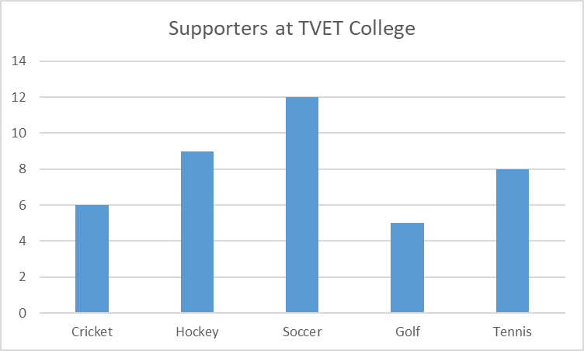  1.4.2  ✓  ✓ | ✓
✓  ✓  One mark for each correct bar. | (5)

1.4.3
SPORTS | DEGREE
Cricket | 54°√
Hockey | 81°√
Soccer | 108°√
Golf | 45°√
Tennis | 72°√

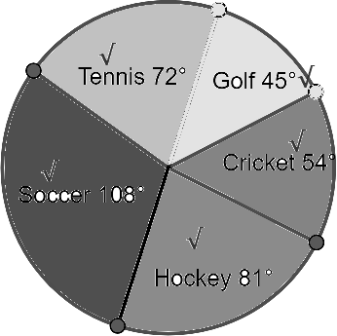

(½ mark for each degree + ½ mark for each correct sector) | (5)
 | [40]

QUESTION 2

2.1 | 2.1.1 | 𝐴 = 2𝜋𝑟ℎ + 2𝜋𝑟²  3 3 ²  = 2𝜋 ( ) (8) + 2𝜋 ( ) ✓  2 2  = 24𝜋 + 4,5𝜋 ✓  = 28,5𝜋 𝑐𝑚² or 89,535 𝑐𝑚² ✓ | (3)

2.1.2 | 𝑉_{𝐵𝐸𝐴𝑀} = 𝑙 × 𝑤 × ℎ  = 12 × 8 × 6 ✓  = 576𝑐𝑚³✓  𝑉𝐶F𝐿𝐼𝑁𝐷𝐴𝑅 = 𝜋𝑟2ℎ  3 2  = 𝜋 ( ) × 8 2  9  = 𝜋 × × 8✓  4  = 18 𝜋 𝑐𝑚³ ✓  = 56,549 𝑐𝑚³  𝑇𝑜𝑡𝑎𝑙 𝑣𝑜𝑙𝑢𝑚𝑒 = 576 + 56,549 + 56,549 ✓  = 689,098 𝑐𝑚³ ✓ | (7)

2.2 2.2.1 𝐷_{𝐴𝐶} = (𝑥₂ − 𝑥₁)² + (𝑦₂ − 𝑦₁)²

=√ (3 − (−1))² + (5 − 2)²✓

=√ (4)² + (3)²✓

= 5✓ (3)

2.2.2 | 𝐷_{𝐵𝐶} = �(𝑥₂ − 𝑥₁)² + (𝑦₂ − 𝑦₁)²  = �(3 − 4)² + (5 − 2)²✓  = �(−1)² + (3)²✓  = √10✓ | (3)

 |  | 2.2.3 | 𝑥1+𝑥2 ; 𝑦1+𝑦2) ✓  M𝐴𝐶 ( 2 2  = −1+3 ; 2+5) ✓  (  2 2  = (1; 7 ✓  )  2 |  | (3)
 | 2.2.4 |  | 𝑦₂ − 𝑦₁  𝑀 = ✓  𝑥₂ − 𝑥₁  5 − 2  = ✓  3 − (−1)  = 3 ✓  4  𝜃𝜃 = tan⁻¹ (3 ✓  )  4  = 36,87^{𝑜} ✓
 |  |  |  | (5)
2.3 | 2.3.1 |  | (0; 0)✓✓ | (2)

2.3.2 | (-2; 5)✓✓ | (2)

2.3.3 | (5; -3)✓✓ | (2)
 |  | [30]

QUESTION 3

3.1 | 3.1.1 | 𝑥² + 𝑦² = 𝑟²  𝑟 = �(2)² + (1)²✓  = √5 ✓ | (3)

 | 3.1.2 | tan 𝜃 =Opposite  Hypotenuse ✓  = 1  2✓ | (2)

 | 3.1.3 | cos 𝜃 =adjacent  Hypotenuse✓  = 2  √5✓ | (2

 | 3.1.4 | Sin𝜃 =opposite  Hypotenuse✓  = 1  √5 ✓ | (2)

 | 3.1.5 | 3𝑐𝑜𝑠𝜃 + 2sin  3 x 2 + 2 x 1 ✓✓  √5 √5  ✓ |  | (3)

3.2.1

x | 0° | 30° | 60° | 90° | 120° | 150° | 180° | 210° | 240° | 270° | 300° | 330° | 360^{𝑜}
f (x) = sin x +1  ✓ | 2 | 1,73 | 1 | 0 | -1 | -1,73 | -2 | -1,73 | -1 | 0  √ | 1 | 1,73 | 2
g(x) = 2cos x  ✓ | 1 | 1,5 | 1,86 | 2 | 1,86 | 1,5 | 1 | 0,5 | 0,13 | 0  √ | 0,13 | 0,5 | 1

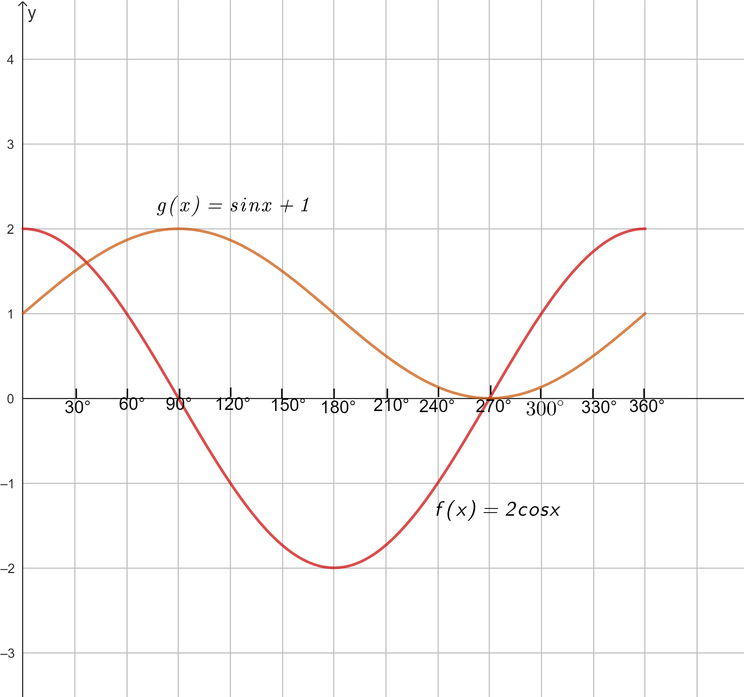
√
√
√
√
√
√
√
√
(3 for table + 5(10× ½) for graph)
2✓✓ shapes
√
3.2.2 | 2✓✓ | (2)

3.2.4 Range of 𝑔(𝑥): 0 ≤ 𝑦 ≤ 🗸2 𝑜𝑟 [0; 2] ✓
3.2.3 | 360º ✓✓ | (2)

Domain of 𝑔(𝑥): 0° ≤ x ≤🗸360° or [0º; 360º] ✓ (2)
3.2.5 | Continuous ✓✓ | (2)

[30]
TOTAL: | 100

√

3.2.2 | 2✓✓   | (2)

